Let’s Build A Snowman……
November 18th 10:00 am to 12:00 pm
Sign up at the Dundee Library and pick up your supply list!

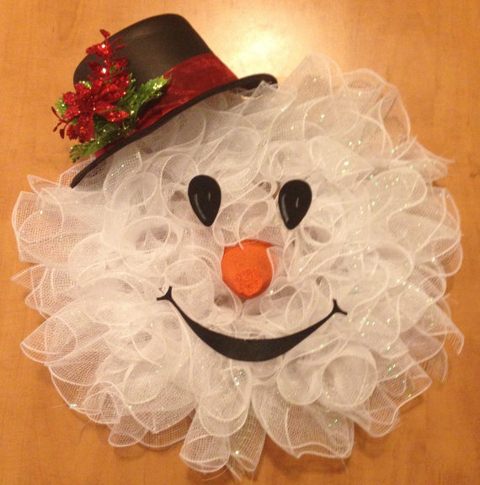

Stephanie Crane will be at the library to show everyone how to build a snowman wreath similar to the one pictured above. The items listed below are all the supplies that are needed to be brought to the class. There is no additional fee for this class.

